~Switching Basic Theory:-
- Open Cisco Packet Tracer or any network simulator, create a simple network with one switch and two PCs, and use the 'show mac address-table' command to observe how the MAC address table is initially empty.
Practical: Observe an Initially Empty MAC Address Table:
1. Create the topology:
In Cisco Packet Tracer, add:
PC1 ───── Switch0 ───── PC2
Use Copper Straight-Through cables.
- PC1 → Switch0 Fa0/1
- PC2 → Switch0 Fa0/2
2. Configure the PCs:
PC1
- IP Address: 192.168.1.10
- Subnet Mask: 255.255.255.0
PC2
- IP Address: 192.168.1.20
- Subnet Mask: 255.255.255.0

3. Check the MAC address table:
Click Switch0 → CLI and enter:
enable
show mac address-table
You may initially see an empty dynamic MAC table, for example:
Vlan Mac Address Type Ports
---- ----------- -------- -----
Note: Packet Tracer may show some entries depending on whether frames have already been exchanged. If the table isn't empty, wait for the interfaces to come up, then clear the dynamic entries and check again:
clear mac address-table dynamic
show mac address-table
4. Observation:
Before the PCs send Ethernet frames, the switch has not learned their MAC addresses dynamically.
The switch learns a MAC address when it receives a frame and records the source MAC address + incoming port in its MAC address table.
Result: The MAC address table starts with no dynamically learned PC entries. After traffic is generated, the switch will automatically learn and add the PCs' MAC addresses.

- Send a ping from PC1 to PC2 in your simulated network, then immediately run 'show mac address-table' on the switch and note how the MAC addresses of both PCs appear in the table.<br><br><em><strong>Hint:</strong> Try pinging in both directions to see how the table updates.</em>

Practical: Observe MAC Address Learning After Ping:
Use the same topology:
PC1 ───── Switch0 ───── PC2
Fa0/1 Fa0/2
1. Check PC IP addresses:
PC1
- IP: 192.168.1.10
- Mask: 255.255.255.0
PC2
- IP: 192.168.1.20
- Mask: 255.255.255.0
2. Find PC1's MAC address:
On PC1 → Desktop → Command Prompt:
ipconfig /all
Note the Physical Address.
Do the same on PC2:
ipconfig /all
3. Ping PC2 from PC1:
On PC1:
ping 192.168.1.20
Expected result:
Reply from 192.168.1.20: bytes=32 time<1ms TTL=128
4. Check the switch MAC table:
Immediately go to Switch0 → CLI:
enable
show mac address-table
You should see entries similar to:
Vlan Mac Address Type Ports
---- ----------- -------- -----
1 00AA.BBCC.DD01 DYNAMIC Fa0/1
1 00AA.BBCC.DD02 DYNAMIC Fa0/2
The actual MAC addresses will be different on your Packet Tracer PCs.
5. Understand what happened:
When PC1 sends the ping:
- The switch receives the frame from Fa0/1.
- It learns PC1's source MAC → Fa0/1.
- PC2 receives the frame and sends a reply.
- The switch receives PC2's reply on Fa0/2.
- It learns PC2's MAC → Fa0/2.
So the switch now knows:
PC1 MAC ── Fa0/1
PC2 MAC ── Fa0/2
6. Try the reverse direction:
From PC2:
ping 192.168.1.10
Then check again:
show mac address-table
The table should still contain both MAC addresses.
Result:
Before ping: MAC table has no dynamically learned PC entries.
After ping: The switch learns and displays the MAC addresses of both PC1 and PC2, associated with their respective switch ports.
Conclusion: A switch dynamically learns MAC addresses by examining the source MAC address of incoming frames and associating each address with the port on which it was received.

- Add a third PC to your network, connect it to the switch, and ping from PC3 to PC1. Observe and record how the MAC address table changes after this communication.

Practical: Add PC3 and Observe MAC Address Table
Network Topology:
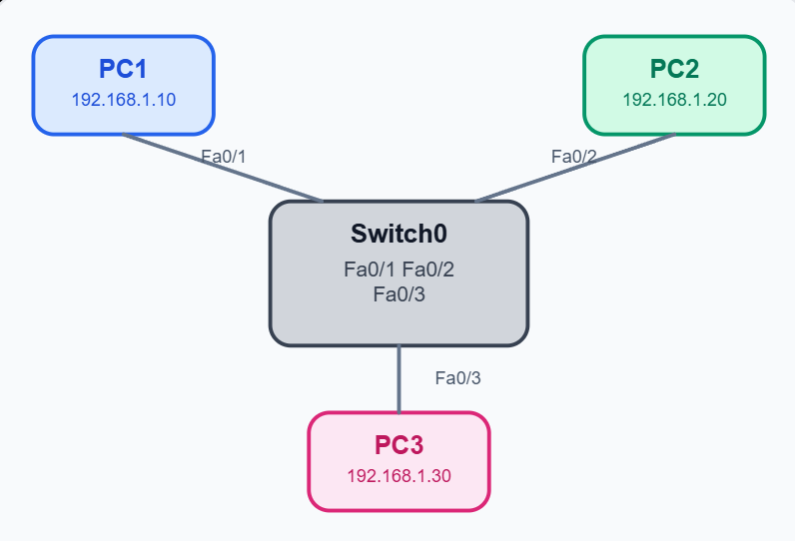

Connect PC3 to Switch0 Fa0/3 using a Copper Straight-Through cable.
Step 1: Configure PC3
Open PC3 → Desktop → IP Configuration.
IP Configuration
IP Address | 192.168.1.30
Subnet Mask | 255.255.255.0
Default Gateway | Leave blank
All three PCs are now in the same network.
PC addressing
PC1 | 192.168.1.10 | Fa0/1
PC2 | 192.168.1.20 | Fa0/2
PC3 | 192.168.1.30 | Fa0/3
Step 2: Ping from PC3 to PC1
Open PC3 → Desktop → Command Prompt and type:
ping 192.168.1.10
Expected result:
Reply from 192.168.1.10: bytes=32 time<1ms TTL=128
Reply from 192.168.1.10: bytes=32 time<1ms TTL=128
Reply from 192.168.1.10: bytes=32 time<1ms TTL=128
Reply from 192.168.1.10: bytes=32 time<1ms TTL=128
The ping should be successful.
Step 3: Check MAC address table
On Switch0 → CLI:
enable
show mac address-table
Example output:
Mac Address Table
-------------------------------------------

Vlan Mac Address Type Ports
---- ----------- -------- -----
1 00AA.BB11.1111 DYNAMIC Fa0/1
1 00AA.BB22.2222 DYNAMIC Fa0/2
1 00AA.BB33.3333 DYNAMIC Fa0/3
Note: Your MAC addresses will be different in Packet Tracer.
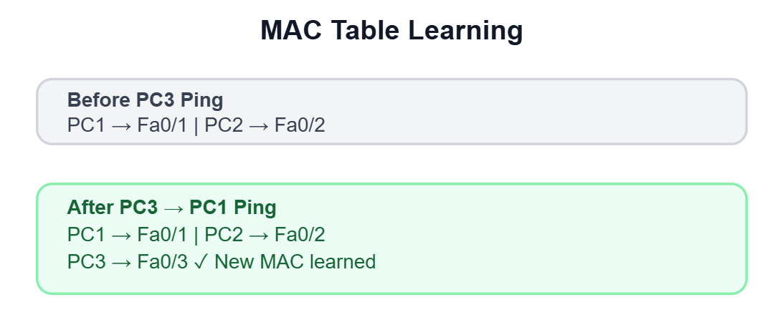
When PC3 sends a ping:
- The switch receives a frame on Fa0/3.
- It learns PC3's source MAC address and stores it with Fa0/3.
- PC1 replies from Fa0/1, confirming its MAC entry.
- PC2's existing entry remains unchanged.
Record for practical file:
PC | MAC Address | Switch Port
PC1 | XXXX.XXXX.XXXX | Fa0/1
PC2 | XXXX.XXXX.XXXX | Fa0/2
PC3 | XXXX.XXXX.XXXX | Fa0/3
Conclusion:
After communication between PC3 and PC1, the switch dynamically learns the MAC address of PC3 on Fa0/3, and the MAC address table now contains entries for all three connected PCs. This demonstrates how a switch automatically builds its MAC address table using the source MAC addresses of incoming Ethernet frames.

- Suppose you see the following MAC address table on a switch: Port 1 - 00:11:22:33:44:55, Port 2 - 66:77:88:99:AA:BB. If a frame arrives at the switch on Port 1 with destination MAC 66:77:88:99:AA:BB, explain step-by-step how the switch will forward this frame.
Step-by-step forwarding process:
Given MAC table:
Port | MAC Address
Port 1 | 00:11:22:33:44:55
Port 2 | 66:77:88:99:AA:BB
A frame arrives on Port 1 with destination MAC 66:77:88:99:AA:BB.
- Frame arrives: The switch receives the Ethernet frame on Port 1.
- Read source MAC: The switch checks the source MAC address and can learn/update that it is reachable through Port 1.
- Read destination MAC: The switch looks at the destination address:
66:77:88:99:AA:BB
- Search MAC table: The switch finds this MAC address in its table:
66:77:88:99:AA:BB → Port 2
- Forward the frame: Because the destination is known, the switch sends the frame only through Port 2.
- Other ports: The switch does not forward the frame to other ports because it already knows where the destination device is.
Simple flow:
Sender
│
▼
Port 1 → [ SWITCH ] → Port 2 → Destination
│
└── Checks MAC table
66:77:88:99:AA:BB → Port 2
Answer: The switch performs unicast forwarding because the destination MAC is already present in its MAC address table. It forwards the frame from Port 1 to Port 2 only.

- Draw a diagram showing how a switch learns and uses MAC addresses to forward frames in a network with 4 devices, and write a short explanation (3-4 sentences) describing the process in your own words.<br><br><em><strong>Constraint:</strong> Do not copy definitions from the textbook; use your own understanding and examples.</em>
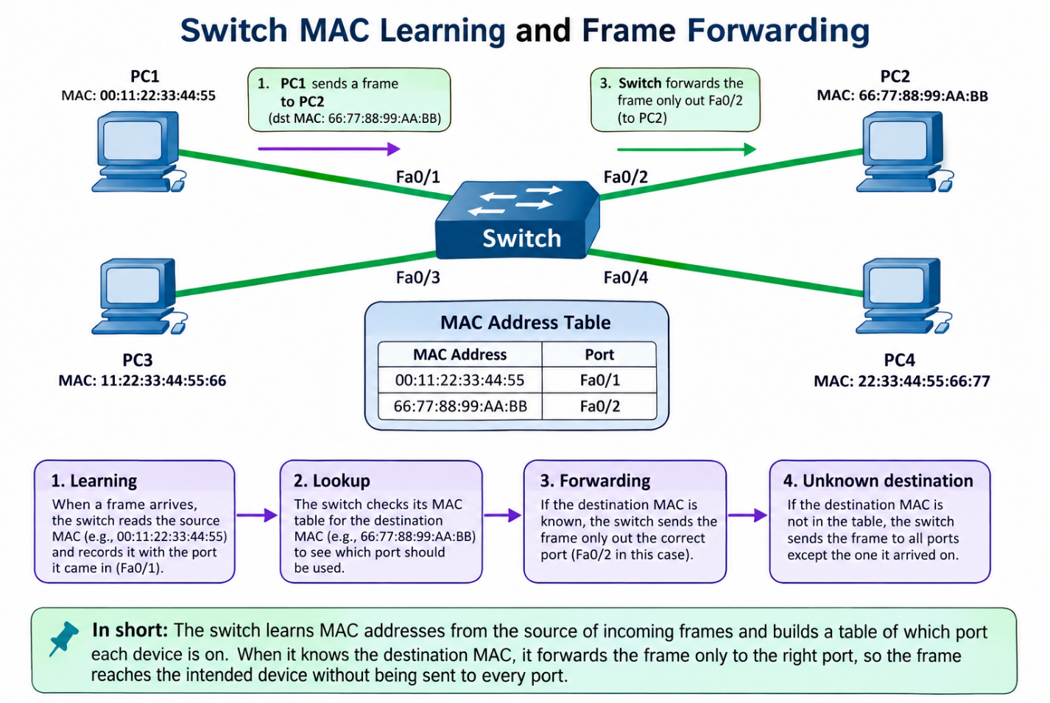

Short explanation:
A switch learns the source MAC address of a device and remembers which port that device is connected to. When a frame arrives, it checks the destination MAC address in its table. If the destination is known, the switch sends the frame only through the correct port; if it is unknown, the switch sends it out through the other ports. As devices communicate, the switch gradually builds a useful MAC address table and forwards frames more efficiently.

THE END…..

